SDLC activity sheets
ACTIVITY SHEET 1 — Requirements Gathering (SRS Development)
Project Title: City Twin – AI-Powered City Hazard Precaution Engine
Team Members: Akhil Chiluvari, Yashwanth Talari, Jitendra D.P. Medisetti, Narsimha Katikeri
Task 1: Stakeholder Interview
- Identify your stakeholders.
Identified Stakeholders
- City residents
- Local government authorities
- Disaster management teams
- Environmental agencies
- System administrators
- Write 8–10 interview questions.
Write your questions below:
- What are the most common hazards faced in cities today?
- How do people currently get information about city hazards?
- What problems exist in current warning systems?
- How early should a hazard warning ideally be provided?
- What type of precautions are most useful for citizens?
- Should the system be simple or feature-rich?
- How important is accuracy vs speed in predictions?
- Should the system support multiple languages?
- Who should have access to detailed hazard data?
- How often should the system be updated?
Task 2: Extract Requirements
Fill the table:
Requirement ID | Type | Requirement Description
R1 | Functional | System shall predict potential city hazards using AI models
R2 | Functional | System shall display hazard levels and precaution suggestions
R3 | Functional | System shall accept city/environmental input data
R4 | Non-Functional | System shall provide results within acceptable response time
R5 | Non-Functional | System shall be user-friendly and easy to understand

Task 3: User Stories
- As a citizen, I want to know possible hazards in my area so that I can stay safe.
- As a user, I want precaution suggestions so that I can act before a disaster occurs.
- As a city official, I want hazard predictions so that I can plan preventive measures.
- As a user, I want a simple interface so that I can easily understand the results.
- As a system admin, I want accurate data processing so that predictions are reliable.
Format: As a [user], I want [feature], so that [reason].
Deliverable: A mini SRS (1–2 pages)

ACTIVITY SHEET 2 — System Design (High-Level & Low-Level)
Project: City Twin – AI-Powered City Hazard Precaution Engine
Task 1: Create a System Architecture Diagram
Draw or attach:
- Components
- Data flow
- External systems
The City Twin system consists of:
- Frontend: Web interface for user interaction
- Backend: Python-based server handling logic and APIs
- AI Model: Machine learning model for hazard prediction
- Dataset: Historical and environmental data
- External APIs (future): Weather and sensor data sources
Space for Diagram:
(Attach sketch or screenshot)
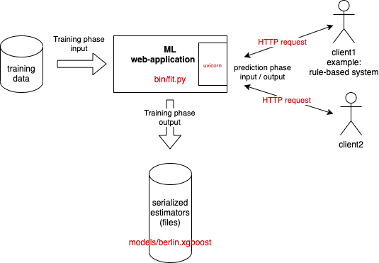
Task 2: Create UI Wireframes
Required screens (tick off as completed):
✔ Home Screen
✔ Main Feature / Hazard Prediction Screen
✔ Result Display Screen
✔ Settings / Language Option Scree
Attach wireframes here.
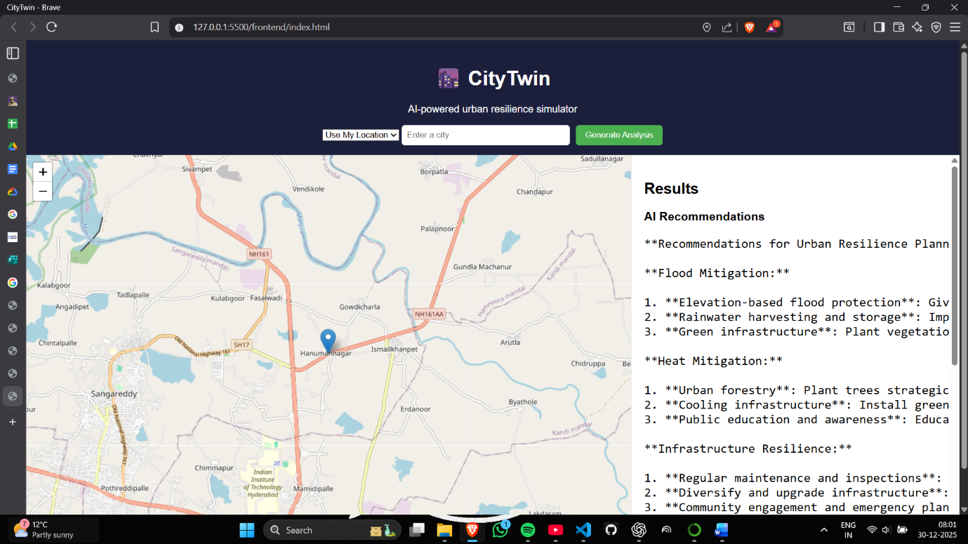
Task 3: Database Design
Create an ERD.
Entity | Attributes
Users | UserID, Name, Location
HazardData | DataID, City, Parameters, Timestamp
Predictions | PredictionID, HazardType, RiskLevel, Precautions

Deliverable: Architecture Diagram + UI Wireframes + ERD

Project Title: City Twin – AI-Powered City Hazard Precaution Engine
ACTIVITY SHEET 3 — Development Phase
Task 1: Break Work into Tasks
Fill the development backlog:
Task ID | Feature | Description | Assignee | Status
T1 | Frontend Setup | Created responsive UI using HTML, CSS, JS for hazard input & map view | Akhil Chiluvari | Done
T2 | Backend API | Developed backend using Python (Flask/Fast API) to handle requests | Akhil Chiluvari | Done
T3 | AI Model Integration | Integrated pre-trained ML model for hazard prediction | Akhil Chiluvari | Done
T4 | Data Processing | Processed environmental & city data for prediction inputs | Akhil Chiluvari | Done
T5 | Frontend–Backend Connection | Connected frontend to backend APIs using fetch/AJAX | Akhil Chiluvari | Done
T6 | Error Handling | Implemented basic error handling & validation | Akhil Chiluvari | Done

Task 2: Code Walkthrough Notes
After writing code, summarize:
- What features were implemented today?
Features Implemented Today
- City hazard prediction based on user input & dataset
- AI model inference through backend API
- Interactive frontend interface
- Map-based hazard visualization

- What blockers did you face?
Blockers Faced
- API connection errors between frontend and backend
- Model input shape mismatch
- Deployment-ready folder structure issues

- Solutions attempted / next steps:
Solutions Attempted / Next Steps
- Fixed API endpoints and CORS issues
- Standardized input preprocessing for ML model
- Modularized backend code
- Prepared app for local and cloud deployment

Deliverable: Updated backlog + coded feature demo

ACTIVITY SHEET 4 — Testing Phase
Task 1: Test Cases
Test Case ID | Description | Steps | Expected Result | Actual Result | Status
TC1 | Flood risk analysis | Input flood data | Correct risk output | As expected | P
TC2 | Heat risk analysis | Input heat data | Correct risk output | As expected | P
TC3 | Recommendation | View suggestions | Proper actions shown | As expected | P

Task 2: Bug Report
Bug ID | Description | Severity | Steps | Status
B1 | UI alignment issue | Low | Load dashboard | Fixed

Task 3: Test Summary
- Total test cases: 3
- Passed: 3
- Failed: 0
- Major issues found: None

Deliverable: Test case sheet + bug report

ACTIVITY SHEET 5 — Deployment & Release Notes
Task 1: Deployment Checklist
Tick as completed:
- Code merged
- Database configured
- Environment variables set
- Build successful
- Final testing done
- Version tagged (v1.0, etc.)
Task 2: Release Notes
Write your Version 1.0 release notes.
Release Version: v1.0
Features Included:
• AI-based city hazard prediction
• User-friendly web interface
• Backend API for real-time inference
• Dataset-driven precaution suggestions
• Map visualization for hazard zones
• Multilingual support (English / Telugu – if enabled)

Known Issues:
• Prediction accuracy depends on dataset quality
• Limited real-time data integration
• UI needs further optimization for mobile devices
Next Update Goals:
• Integrate live weather & sensor APIs
• Improve AI model accuracy
• Add user accounts & history tracking
• Full cloud-scale deployment
• Enhanced UI/UX and performance optimization
Deliverable: Deployment & Release Document

ACTIVITY SHEET 6 — Maintenance & Reflection
Task 1: Fix & Patch Log
Patch ID | Issue | Root Cause | Fix Implemented | Status
P1 | UI issue | CSS alignment | Layout fixed | Done

Task 2: Team Retrospective

What worked well:
Clear planning, modular code, team coordination.
What needs improvement:
Data sources and UI refinement.
What will we change next time:
Earlier testing and better datasets.

